***Security Onion with Traffic Agents Setup***

Network Traffic Evaluation using Network Intrusion Detection System

**Table of Contents**

1 Project Objective 3

2 Prerequisite Knowledge and Skills and Hardware 3

3 Network Topology 4

4 Iptables Configuration 4

5 Security Onion Setup 5

5.1 Setup of Security Onion 5

5.1.1 X11 Client Installation 5

5.1.2 X11 Server Installation 5

5.1.3 Configuration of SIEM 5

5.1.4 Installation of Security Onion 6

5.1.5 Updating of Security Onion 10

5.1.6 Fixing errors in Security Onion 11

5.1.7 Disabling firewall in SIEM 12

5.1.8 Accessing Sguil in Security Onion 12

5.1.9 Accessing Kibana in Security Onion 13

6 Network traffic generation 15

6.1 Normal Network Traffic 15

6.1.1 PyTgen 15

6.1.2 D-ITG 17

6.1.3 Self-Generated User Behavior Traffic 19

6.1.4 Downloaded User Behavior Traffic 24

6.2 Attack Network Traffic 25

6.2.1 Slow Read 25

6.2.2 Flightsim 27

6.2.3 SSH Brute Force 29

6.2.4 Hping3 SYN flood 31

6.2.5 Nmap 34

6.3 Combined Network Traffic 36

6.3.1 Network Traffic generated by Tools 36

6.3.2 Self-Generated User Behavior with Attack Traffic 39

6.3.3 Downloaded User Behavior with Attack Traffic 41

6.4 Conclusion 44

# Project Objective

Network traffic generation is done through open source tools. There are two types of network traffic that I am focusing on which are Normal network traffic and Attack network traffic.

In order to evaluate Security Onion, I must set up different scenarios for the Security Onion to generate alerts.

# Prerequisite Knowledge and Skills and Hardware

Before starting this model, you are expected to have some knowledge in computer, network and various network services, information system, network intrusion detection system and operating system (e.g Linux).

A minimum of 8gb and 4 cpu cores is required for Security Onion installation.

# Network Topology

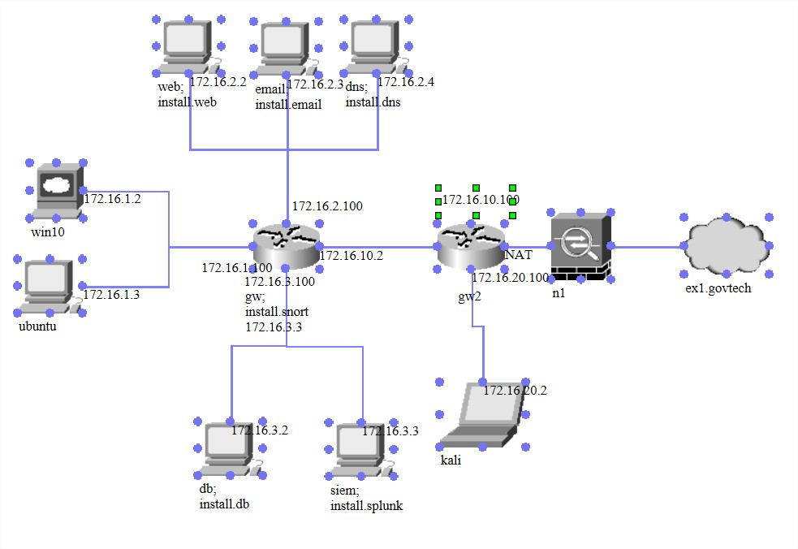

# Iptables Configuration

Adding iptables rule to allow ssh connection from the eth3 interface of the gateway to the SIEM eth2.



I added another iptables rule in the gateway to allow HTTPS connection from the Kali Linux to the SIEM using eth3.



This gateway iptable rule is to duplicate the packets entering eth1 which contains the Ubuntu and eth 2 which contains the web, email and dns server. The duplicated traffic is then transferred to the SIEM eth2 with the ip address of 172.16.3.4.

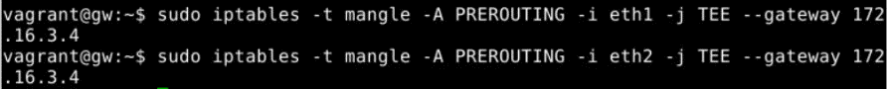

I have only duplicated the incoming packets for Ubuntu and the servers but not the outgoing packets. Thus, I used the POSTROUTING iptable rule in the mangle table to do so.





# Security Onion Setup

Security Onion is a free and open source Linux distribution for intrusion detection, enterprise security monitoring, and log management. It includes Elasticsearch, Logstash, Kibana, Snort, Suricata, Bro, Wazuh, Sguil, Squert, CyberChef, NetworkMiner, and many other security tools.

For this model, I will be focusing only on Kibana, Snort, Bro and Sguil.

Note: This setup should only be followed if the SIEM server does not have GUI and you have another machine that has GUI to connect to it through SSH.

## Setup of Security Onion

### X11 Client Installation

For me to display GUI during the installation, I must use ssh -X from a machine that has GUI to connect to the headless distro SIEM.

X11 Client (SIEM)

Sudo apt-get install xauth

### X11 Server Installation

X11 Server (Kali Linux)

Sudo apt-get install xorg

Sudo apt-get install openbox

### Configuration of SIEM

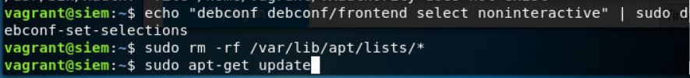

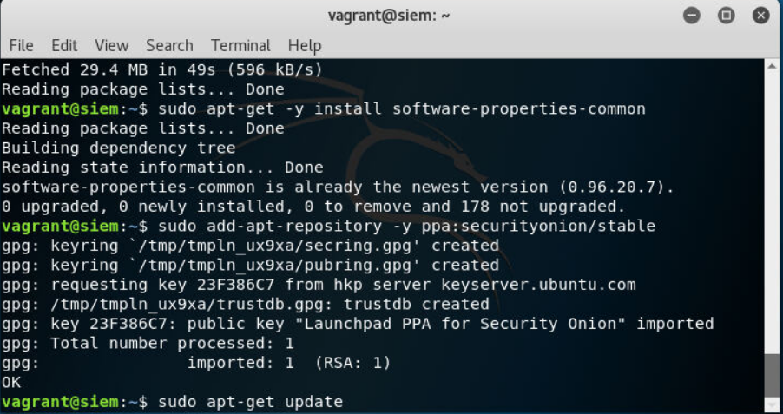

### Installation of Security Onion





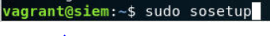

To setup the security onion, run sudo sosetup. I clicked on Yes, configure /etc/network/interfaces.

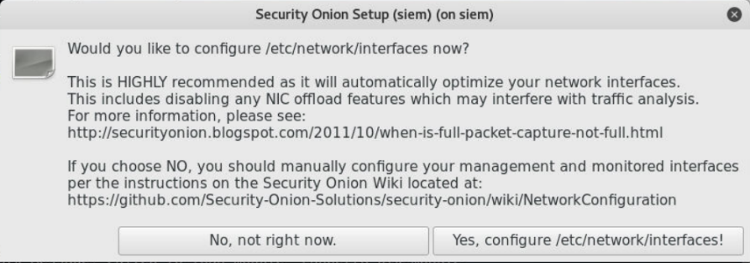

I choose the management interface eth2.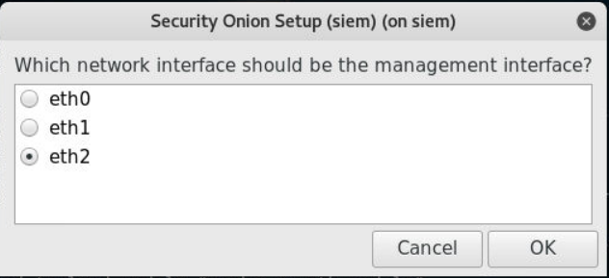

It’s okay to choose either static or DHCP for now as I can configure it later through /etc/network/interfaces file.

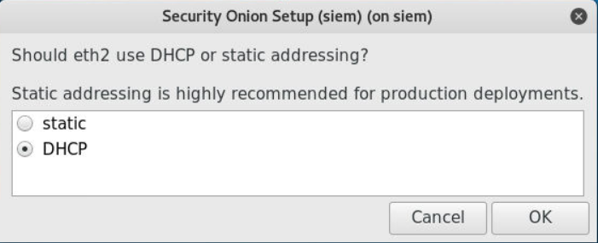

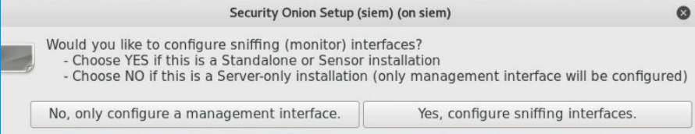

Click on yes and choose eth1 for sniffing.

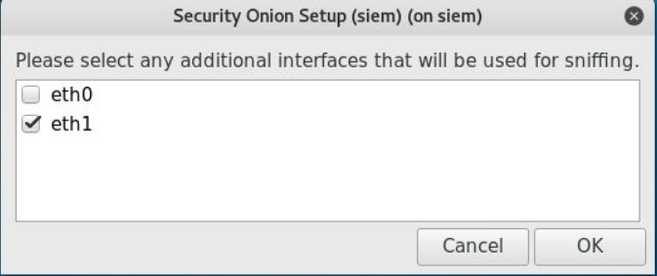

Click on Yes, make changes.

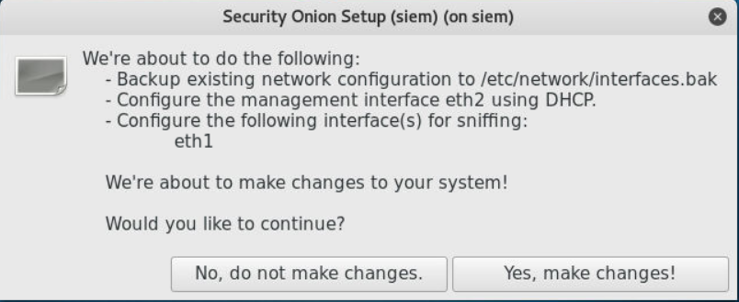

Click on Reboot.

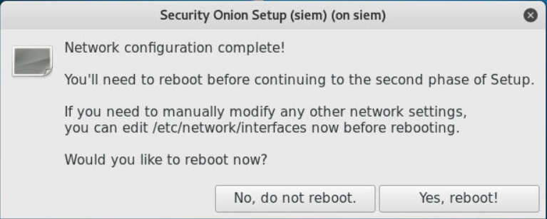

After rebooting, I changed the /etc/network/interfaces file to the following. Eth1 remains untouched as it is the sniffing interface.

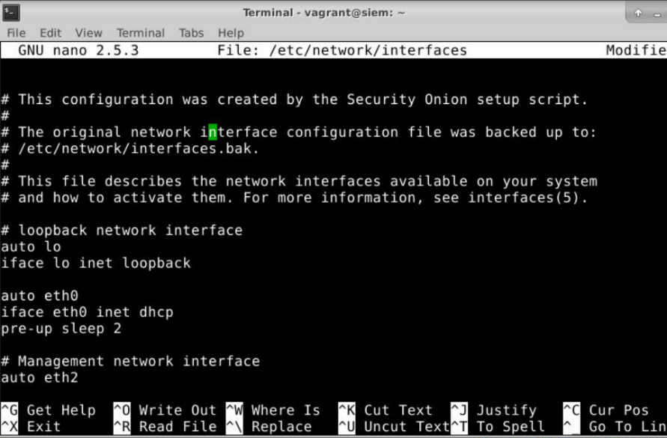

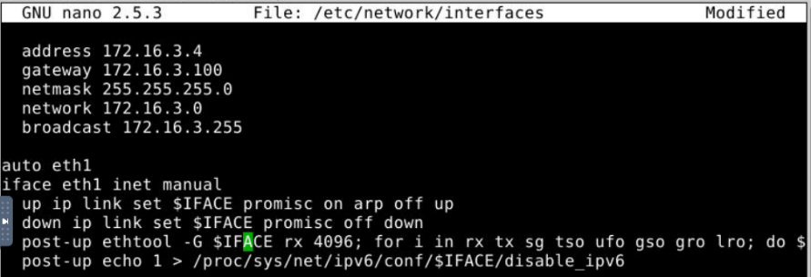

Click on Yes, skip network configuration.

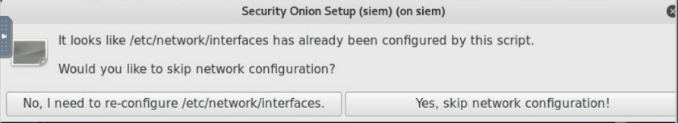

I click on Evaluation mode as I am doing a small-scale experiment.

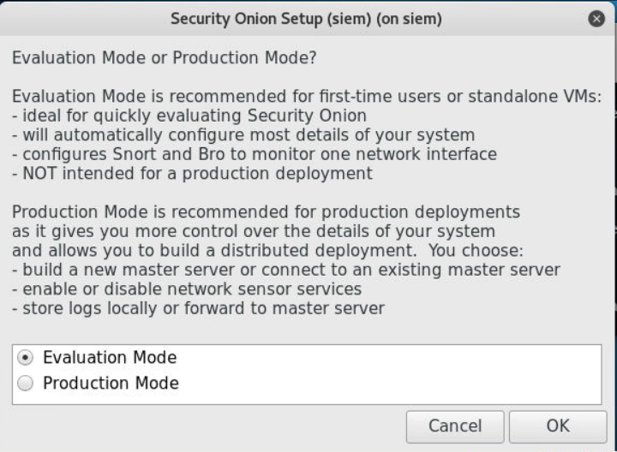

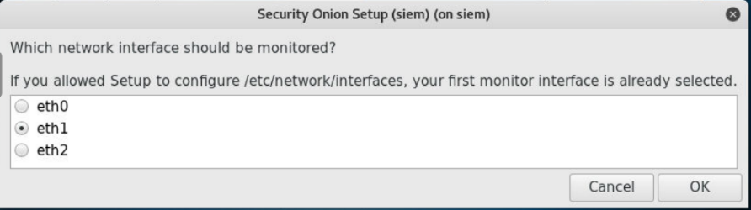

I created the user named seconion with the password seconion.

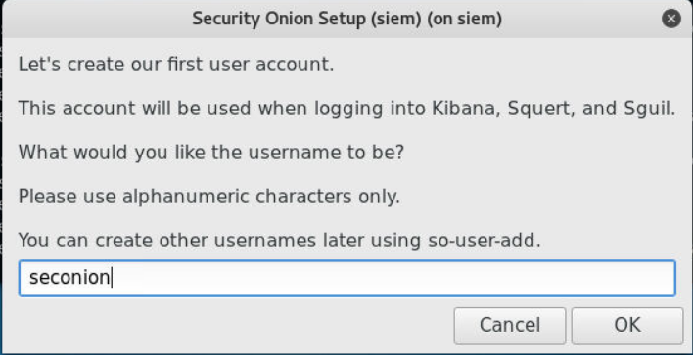

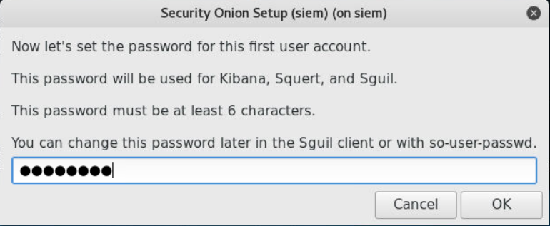

I click on Yes, proceed with the changes.

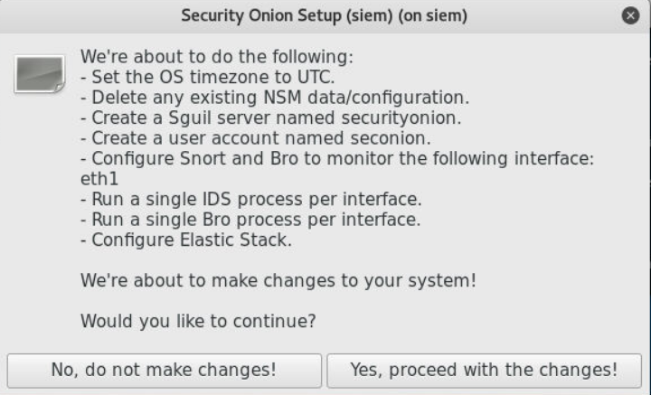

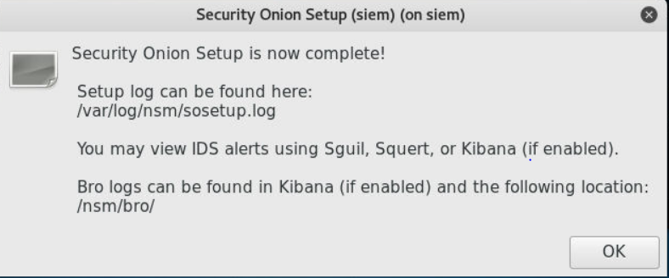

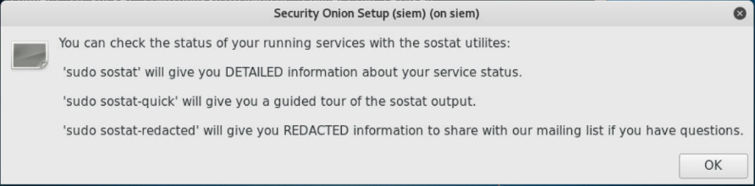

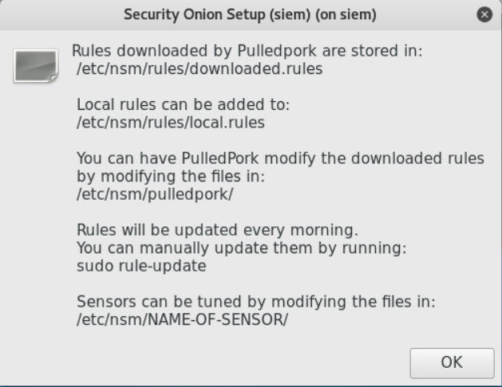

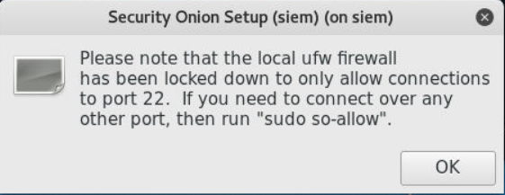

### Updating of Security Onion

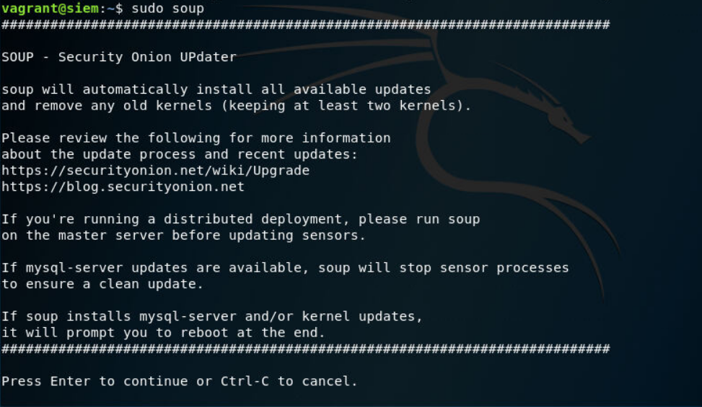

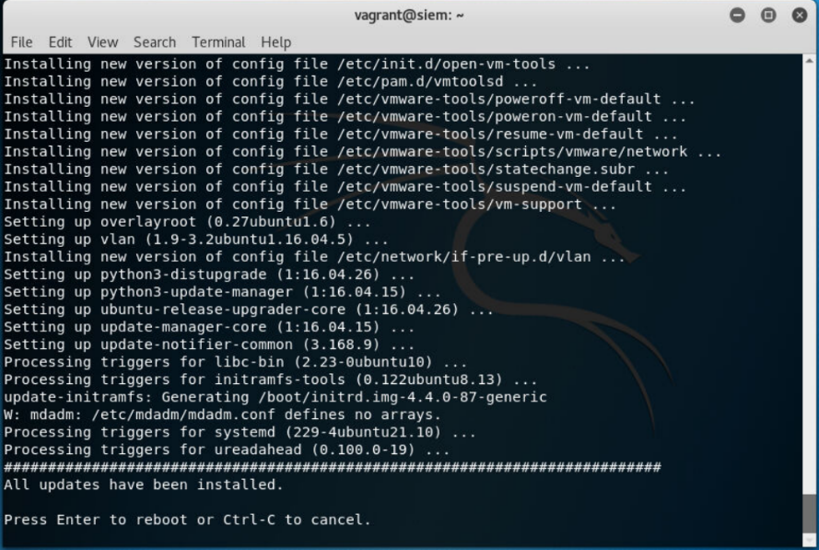

### Fixing errors in Security Onion

I encountered some errors when sguil.tk, error states that file is missing. Thus, I created the snort-1.stats file using sudo touch. I restarted the security onion sensor.

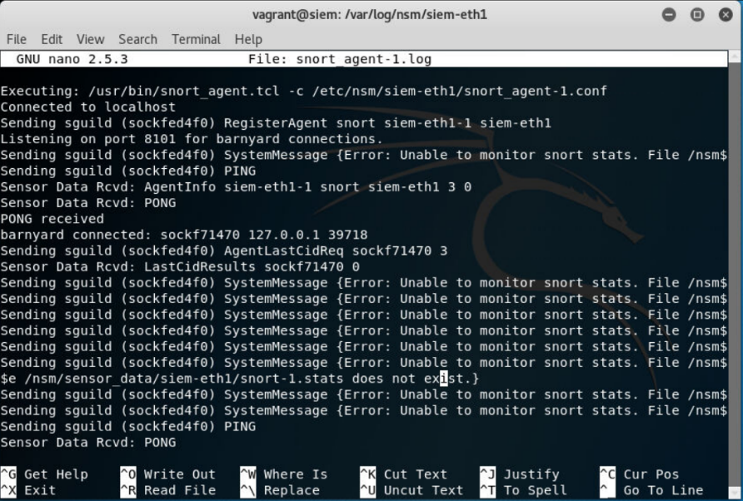



### Disabling firewall in SIEM



### Accessing Sguil in Security Onion



Log in using the username: seconion, password: seconion

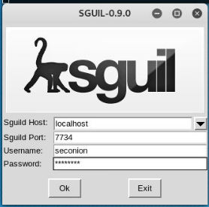

Ignore siem-ossec as we are only testing NIDS for this project. Click on Start SGUIL.

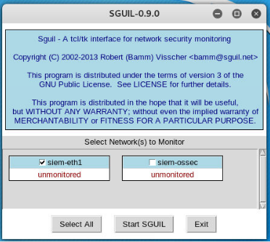

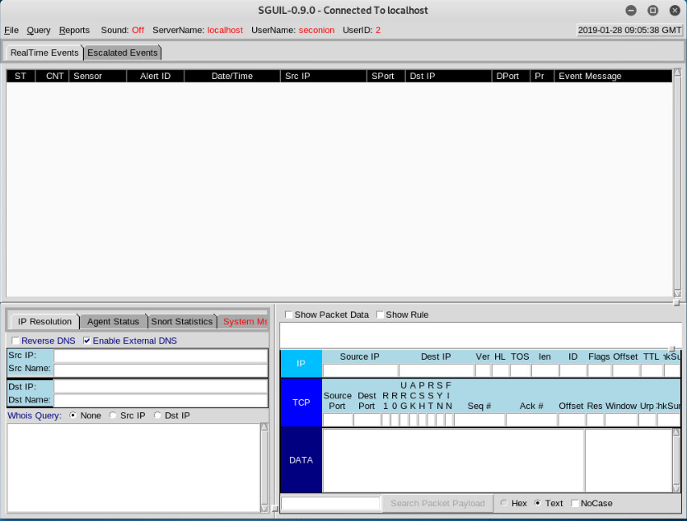

### Accessing Kibana in Security Onion

Enabling the exception in Firefox when connecting to <https://172.16.10.2/> through Kali Linux to gateway.

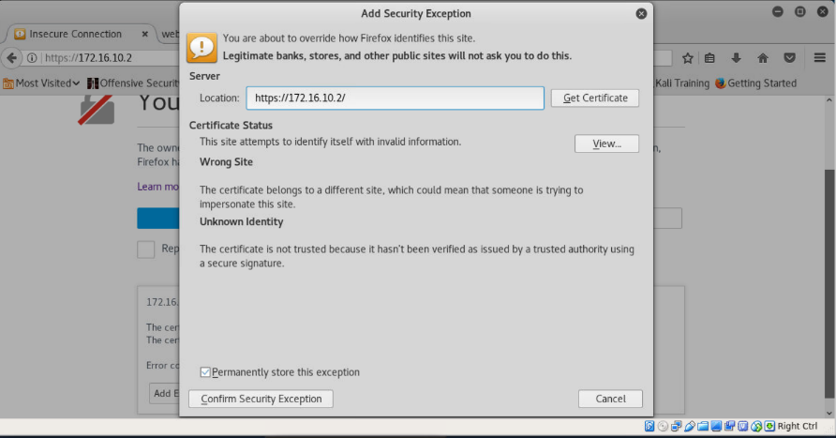

Click on Kibana.

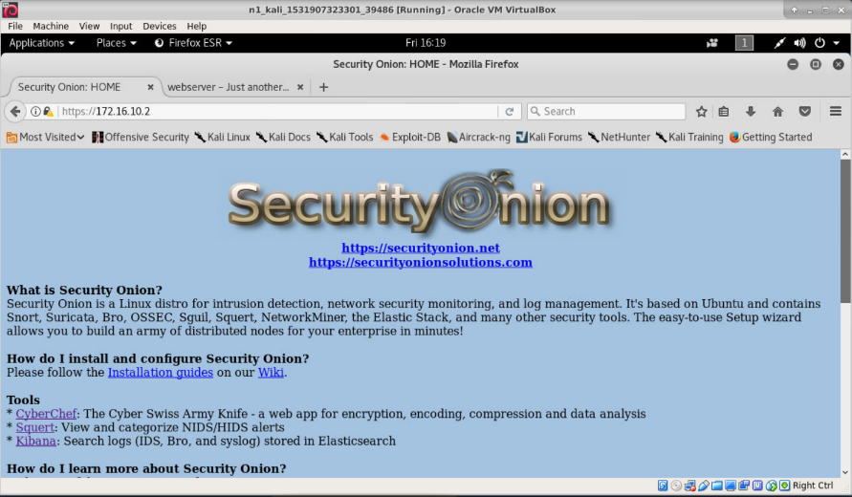

Log in using the username: seconion, password: seconion

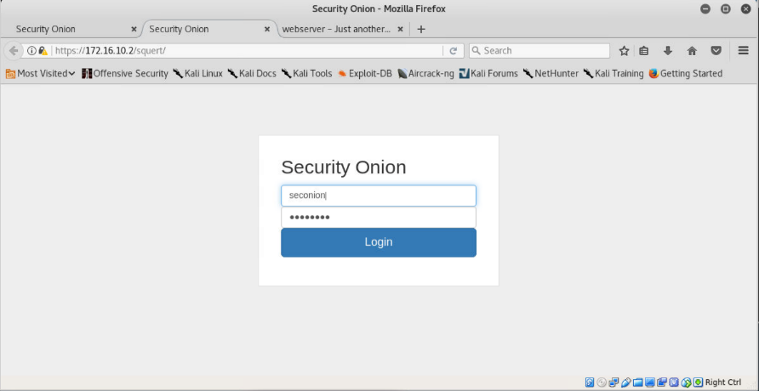

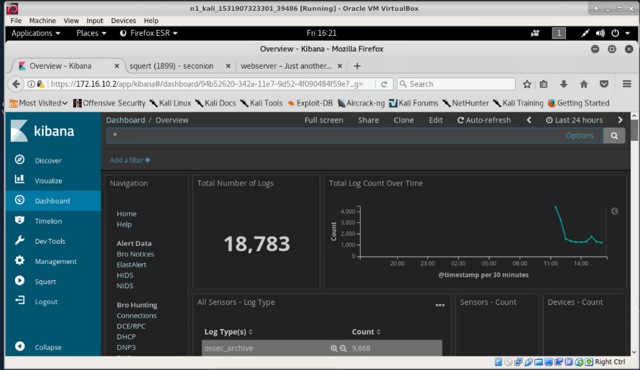

# Network traffic generation

To simulate a normal network, I will be generating normal network traffic with the attack normal traffic.

I am tasked to set up different scenarios where the attacker which is in the external network is attacking the internal network using different tools provided and downloaded in Kali Linux.

I shall act as attacker/pentester and conduct these practices from a dedicated kali workstation.

Assumption: Attacker has already compromised the Internal Network’s Ubuntu virtual machine.

## Normal Network Traffic

### PyTgen

I will be generating ping and http traffic using PyTgen traffic generation tool.

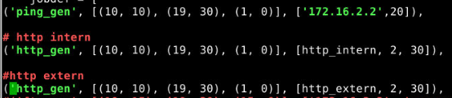





<https://github.com/reissmann/PyTgen>

#### Sguil

Snort generated one type of alert due to Suspicious User Agent. This is probably due to a tcp established connection a server using HTTP. Snort suspects it is an attempted reconnaissance.

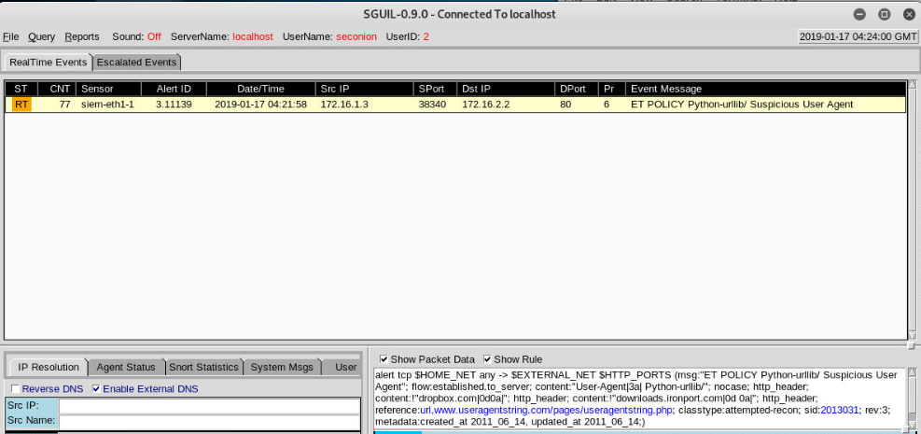

#### Kibana

Snort Alerts

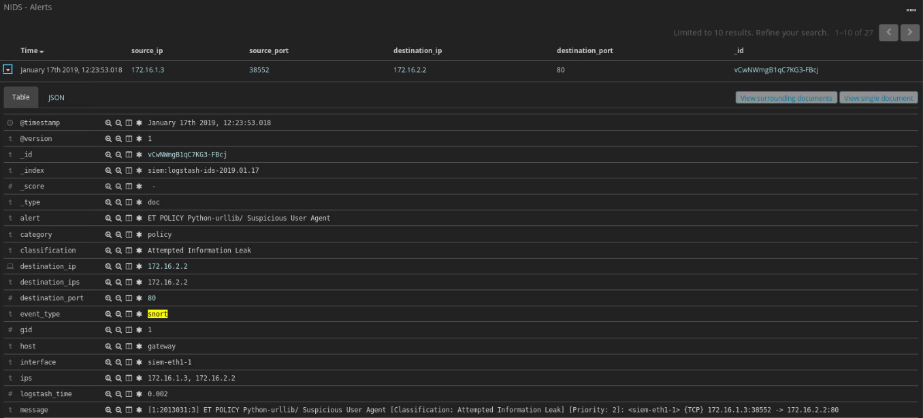

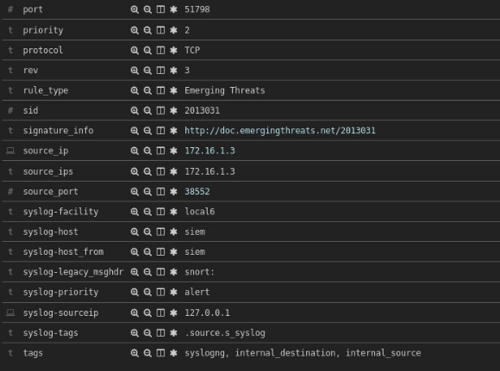

### D-ITG

D-ITG

Receiver: Web (172.16.2.2)

Sender: Ubuntu (172.16.1.3)

The web server will be running the server which receives packets from the sender.

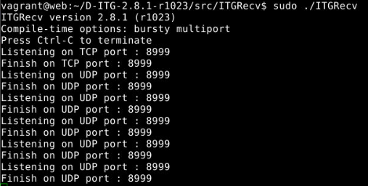

The ubuntu machine will be sending the various application layer options which are Telnet, VoIP, CSi, CSa, Quake3, DNS to the receiving server.

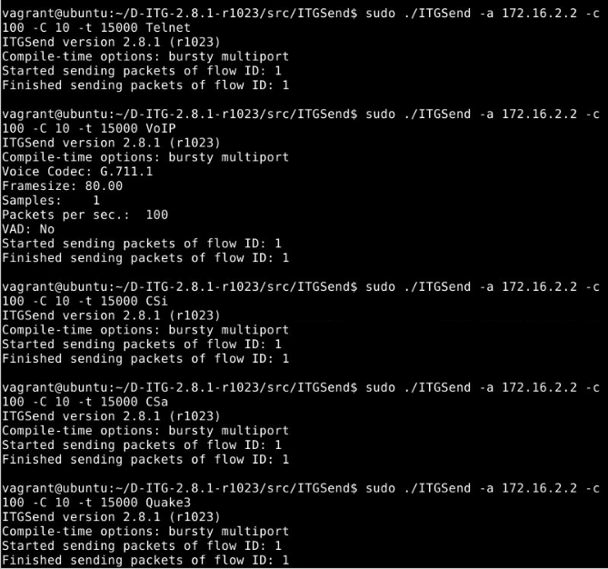

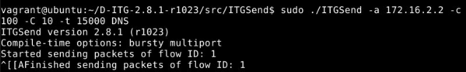

<http://www.grid.unina.it/software/ITG/>

#### Kibana

No alerts.

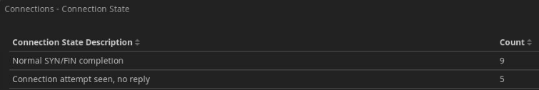\

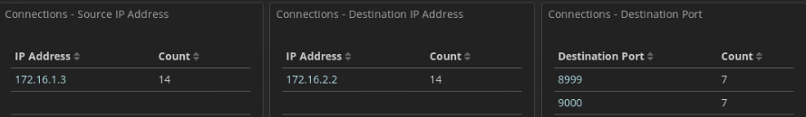

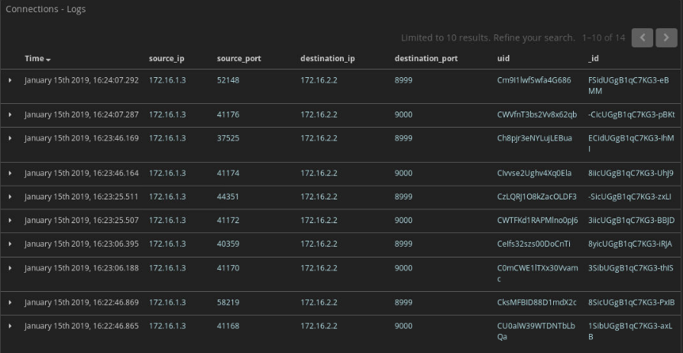

### Self-Generated User Behavior Traffic

#### FTP

**FTP**

Ubuntu: 172.16.1.3

Email: 172.16.2.3

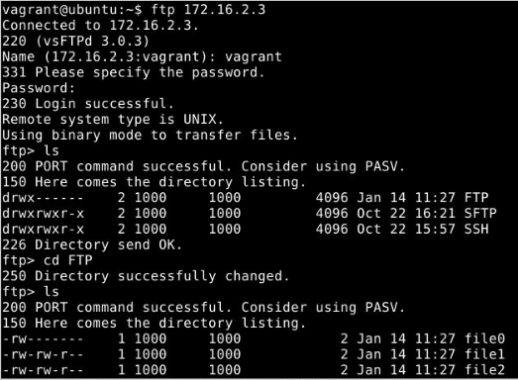

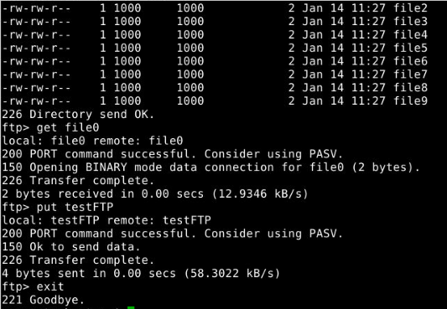

#### SSH

Ubuntu: 172.16.1.3

Web: 172.16.2.2

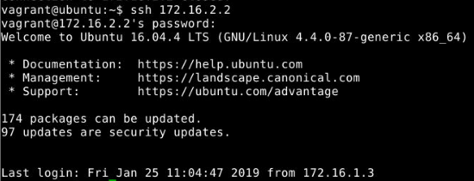

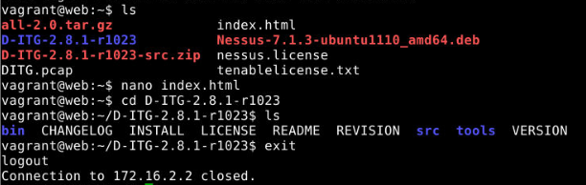

#### ICMP

Ubuntu: 172.16.1.3

Dns: 172.16.2.4

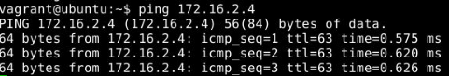

#### Browsing Web pages

Ubuntu: 172.16.1.3

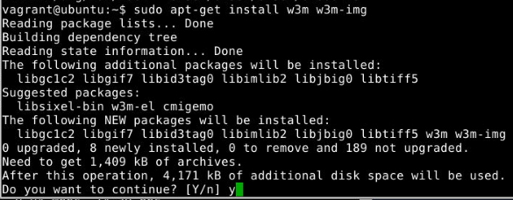



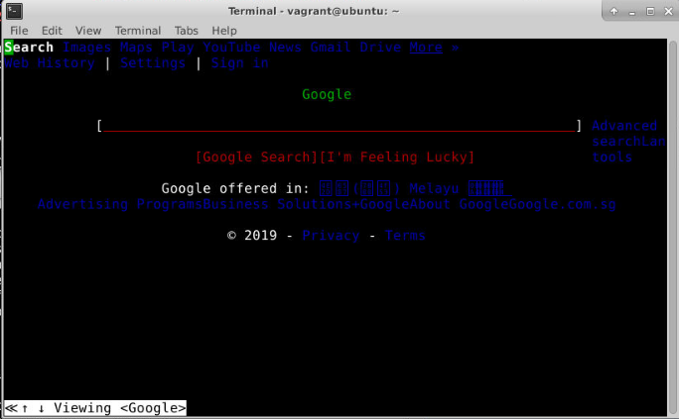

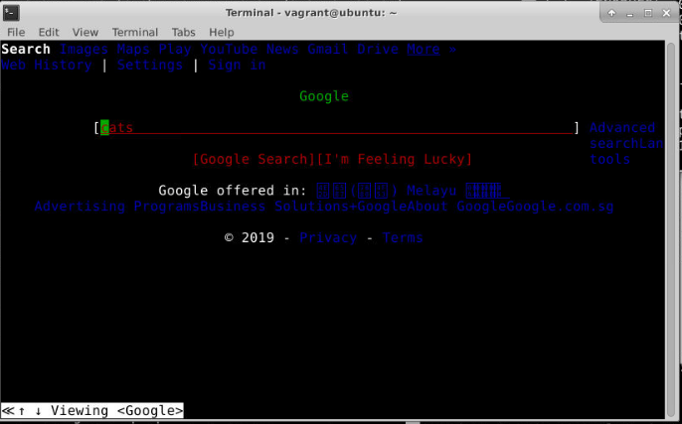

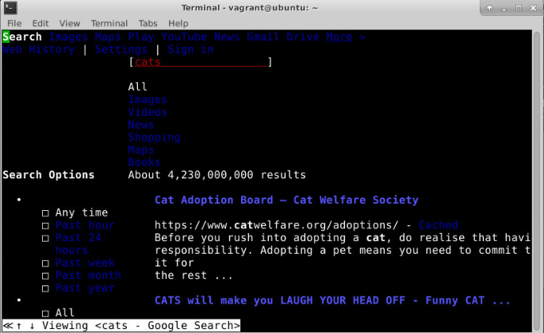

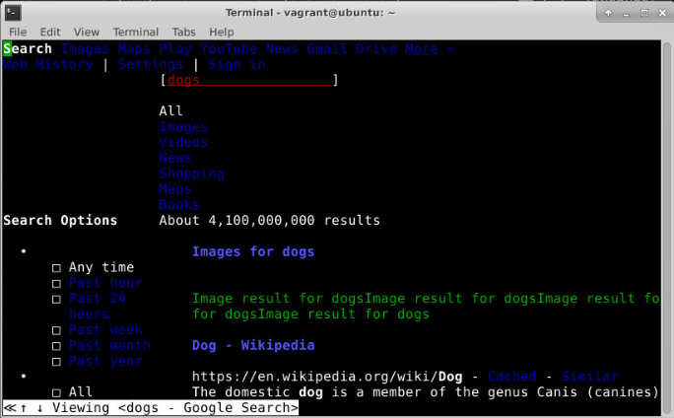

#### 7.1.3.2.1 Sguil

There are many alerts for ICMP and one for SSH Scan and SSH Scan Outbound.

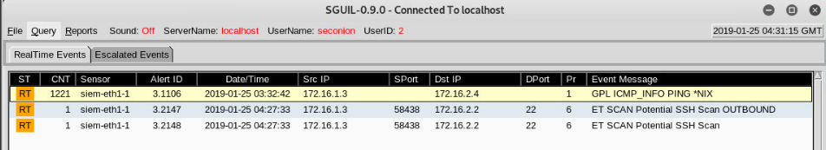

#### 7.1.3.2.1 Kibana

**Snort**

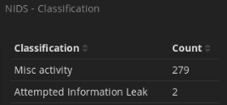

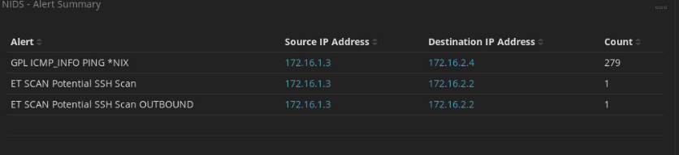

### Downloaded User Behavior Traffic

I downloaded a normal user user behavior-based traffic through the web which contains port 53 and port 43 traffic.

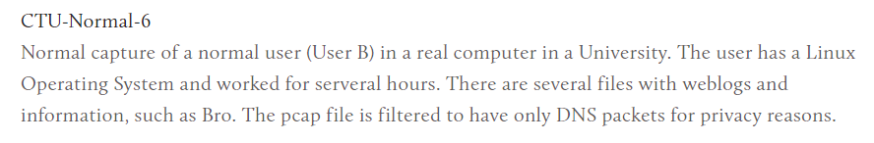

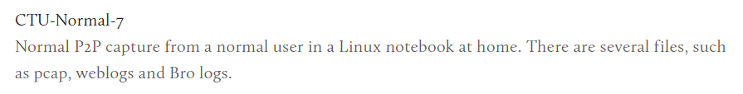

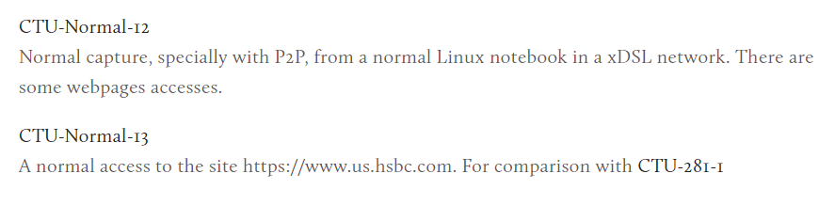

<https://mcfp.felk.cvut.cz/publicDatasets/CTU-Normal-6-filtered/2013-10-21_capture-1-only-dns.pcap>

<https://mcfp.felk.cvut.cz/publicDatasets/CTU-Normal-7/2013-12-17_capture1.pcap>

<https://mcfp.felk.cvut.cz/publicDatasets/CTU-Normal-12/2013-12-17_capture1.pcap>

<https://mcfp.felk.cvut.cz/publicDatasets/CTU-Normal-13/2017-07-03_capture-win2.pcap>

## Attack Network Traffic

### Slow Read

Machines involved:

Kali Linux: 172.16.20.2

Gateway: 172.16.10.2

Web server: 172.16.2.2

Slow Read Attack DoS using Slowhttptest tool installed in Kali Linux to Web server. I will do the attack on the Gateway’s eth3 as I have already done the port forwarding from the gateway eth3 to the web server http port.

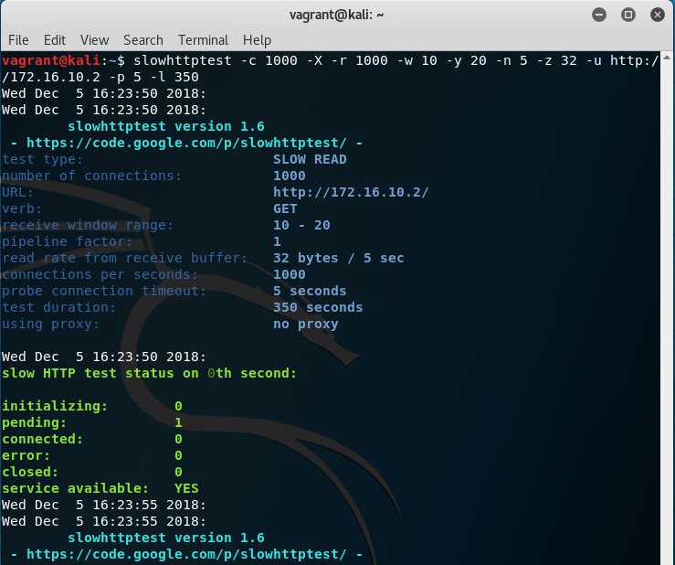

#### Sguil

Snort was able to detect the attack with the rule which contains the referer “slowhttptest”, threshold: both, track by_src, count 15, seconds 30. Bro is unable to detect the Slow Read Attack in the notice but can detect the referrer of the slowhttptest.

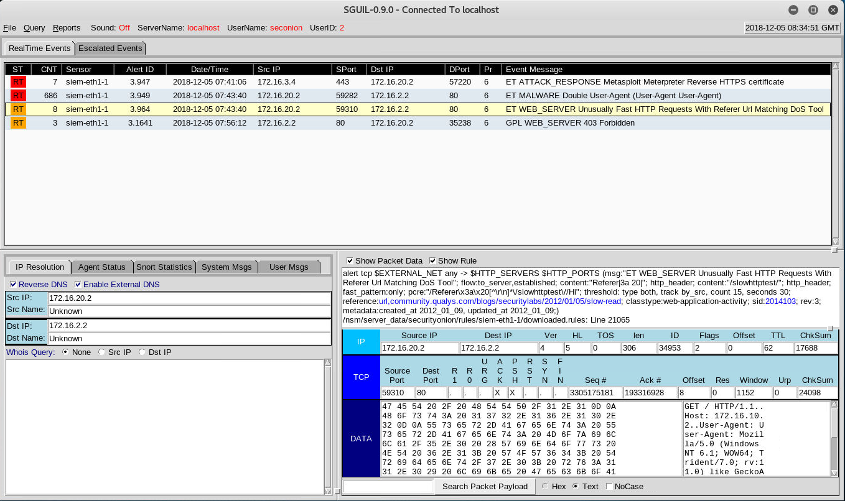  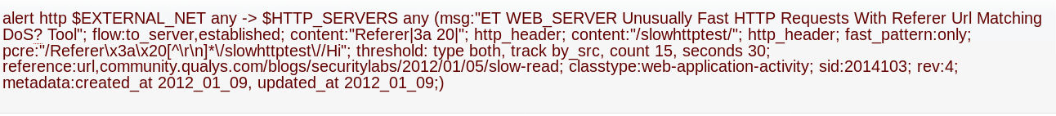

#### Kibana

Under HTTP traffic Referrer, the tool slowhttptest is detected by snort.



Under HTTP User Agent, we can see that the same user is doing the slowhttptest attack.

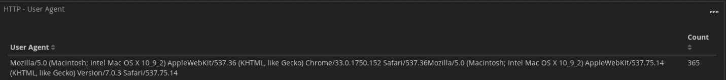

Under HTTP - Logs, we can see that the source ip is Kali Linux and destination ip is web server. The destination port being attacked is port 80 HTTP.

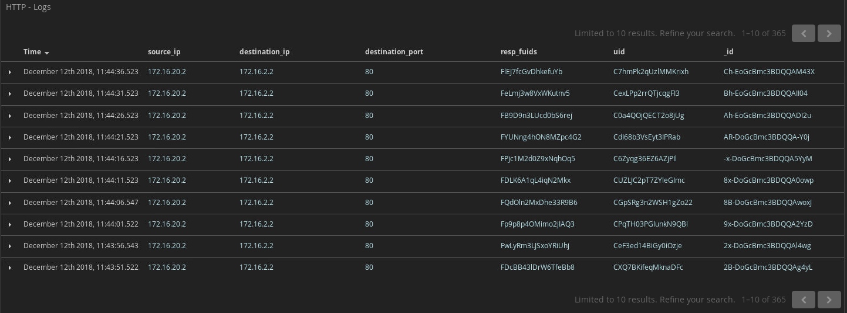

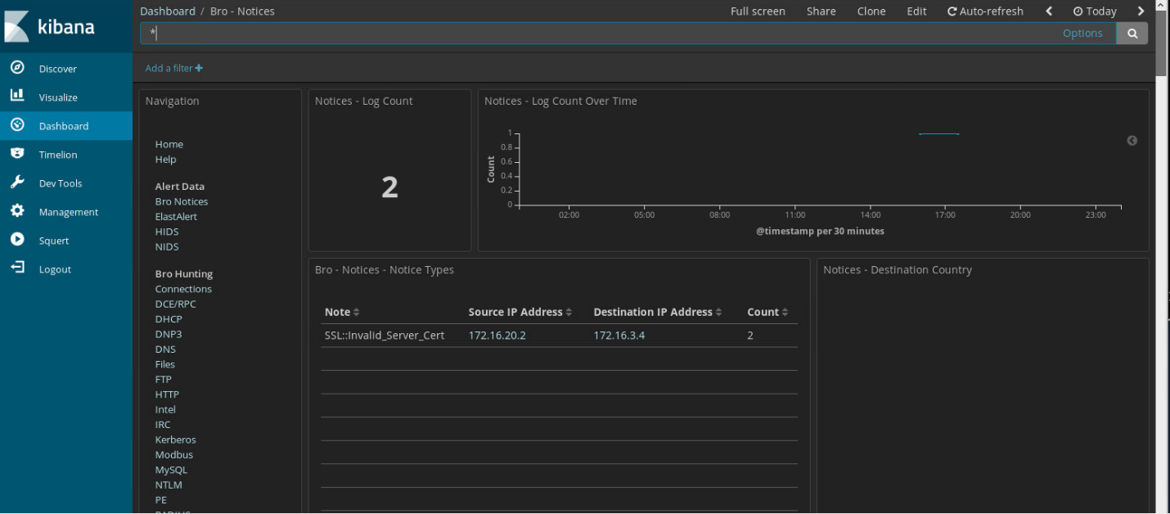

#### 

### Flightsim

Target: Meta3 (172.16.1.4)

Attacker: Ubuntu (172.16.1.3)

Using flightsim attack traffic generator in Ubuntu, I can produce different types of attacks which are c2-dns, c2-ip, dga, hijack, scan, sink, spambot and tunnel.

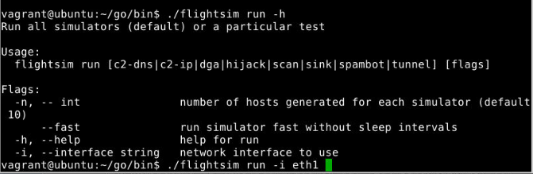

<https://github.com/alphasoc/flightsim>

#### Sguil

Snort was able to detect Inbound to Oracle SQL port 1521 and VNC Scan 5900-5920. Looking at the CNT, there are 5 alerts for Oracle and 1 alert for VNC Scan.

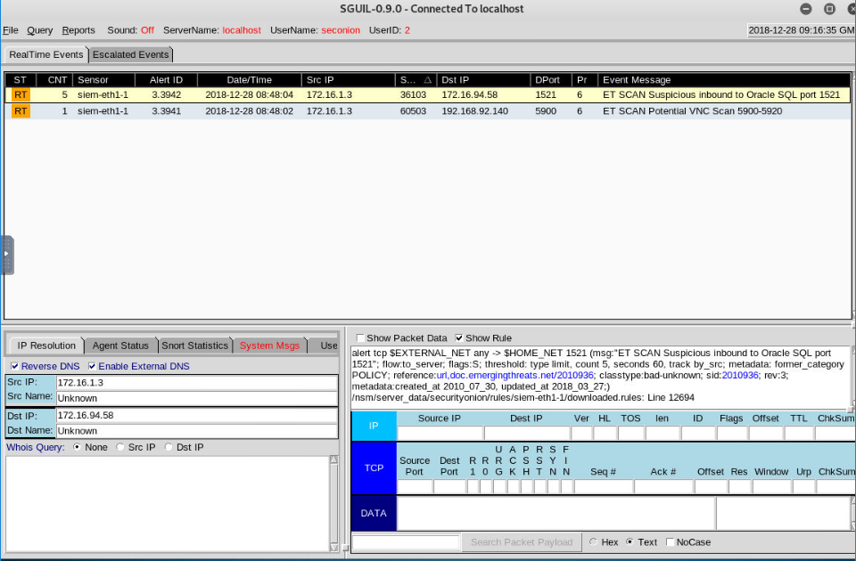

#### Kibana

Bro was able to detect an anomaly that is the Ubuntu workstation scanning at least 25 unique hosts on port 25/tcp in 14 seconds.

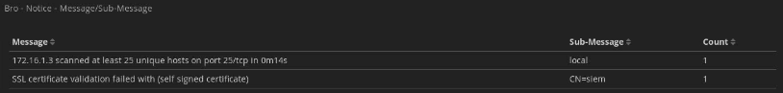

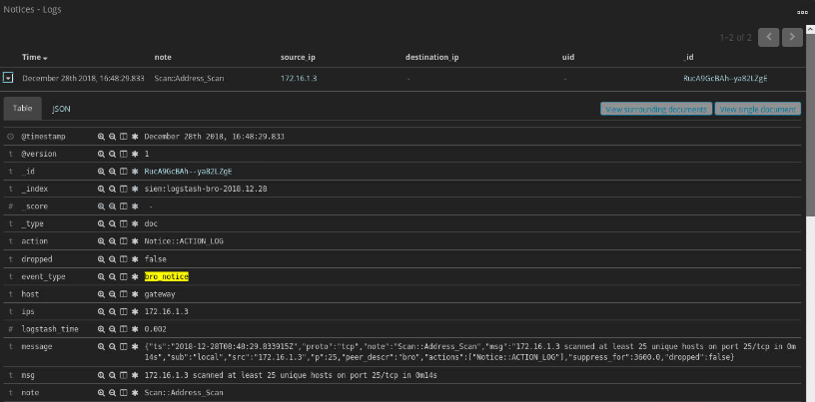

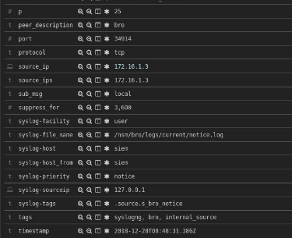

### SSH Brute Force

Target: SIEM (172.16.3.3)

Attacker: Kali Linux (172.16.20.2)

I will perform SSH Brute Force through the msfconsole from Kali Linux to the SIEM which has the Security Onion.

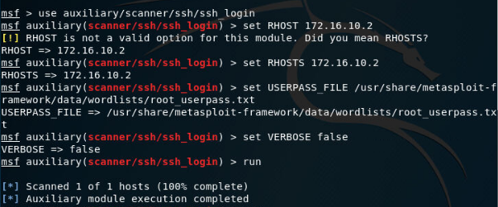

#### Sguil

Snort was able to detect one alert each for both the SSH Scan and SSH Scan Outbound. The source IP address will Kali Linux while the destination IP address will be the SIEM.

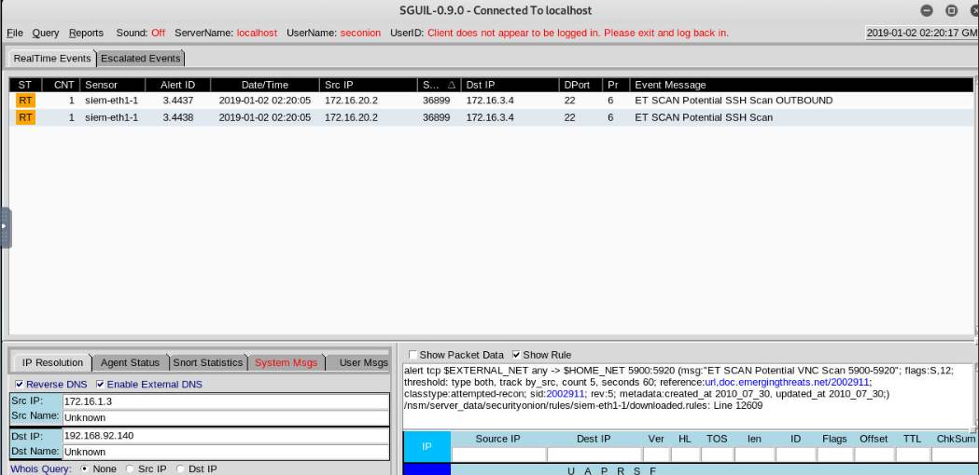

#### Kibana

There are 8 counts of the SSH Scan Outbound and 2 counts of the SSH Scan. The source IP address of 172.16.20.2 is from the Kali Linux while the destination IP address of 172.16.3.4 is the SIEM.

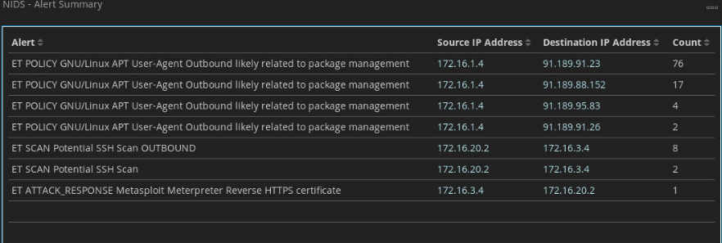

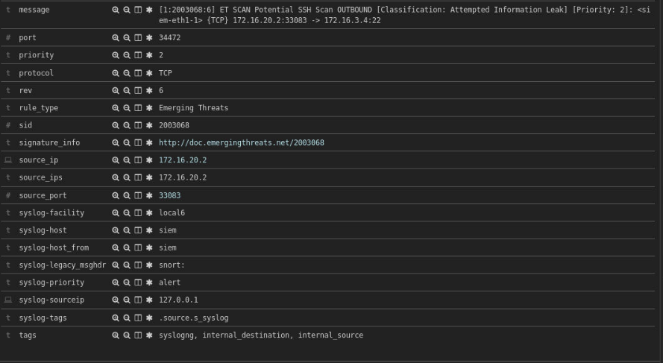

### Hping3 SYN flood

I will be performing the SYN flood on the web server using hping3 tool from the ubuntu workstation.



* --flood: sent packets as fast as possible. Don't show replies.
* --rand-dest: random destionation address mode. see the man.
* -V <-- Verbose
* -c --count: packet count
* -d --data: data size
* -S --syn: set SYN flag
* -w --win: winsize (default 64)
* -p --destport [+][+]<port> destination port(default 0) ctrl+z inc/dec
* -s --baseport: base source port (default random)

#### Sguil

Snort was able to detect 2 alerts of Unusual Port 445 Potential Scan or Infection from the source IP address of 172.16.1.3 and destination IP address of 172.16.2.2 which is the web server.

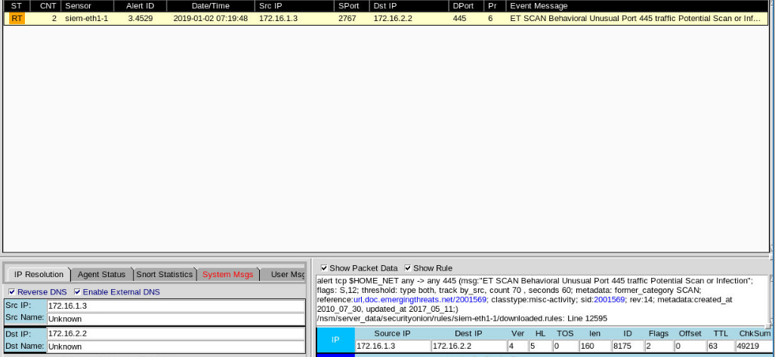

#### Kibana

A total of 1 count is detected by Snort. 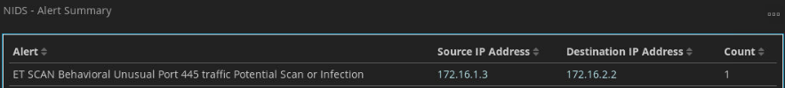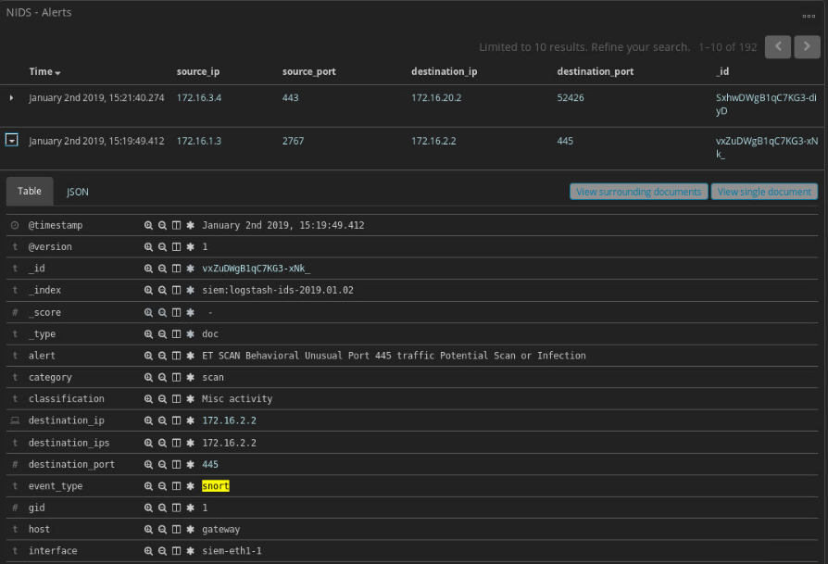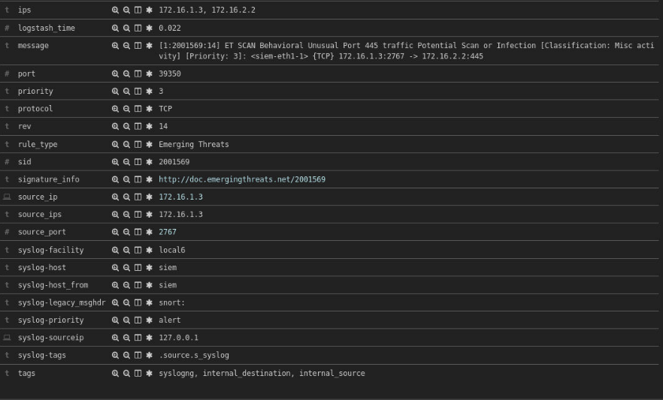

### Nmap

Target: Web (172.16.2.2)

Attacker: Ubuntu (172.16.1.3)

Nmap Application/Service Identification

I performed a nmap scan on the web server from the ubuntu.

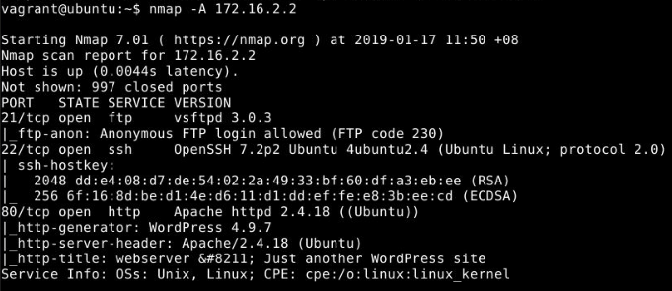

#### Sguil

11 types of Snort alerts detected during the scan.

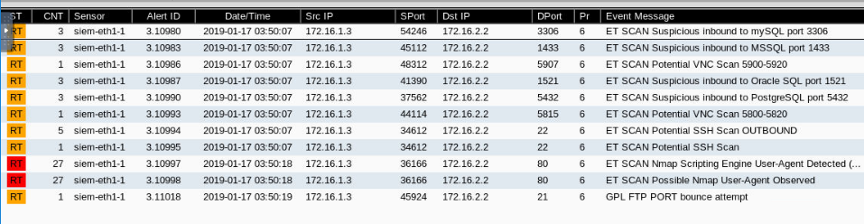

#### Kibana

These are alerts from Snort and the number of counts detected for each individual types of alert.

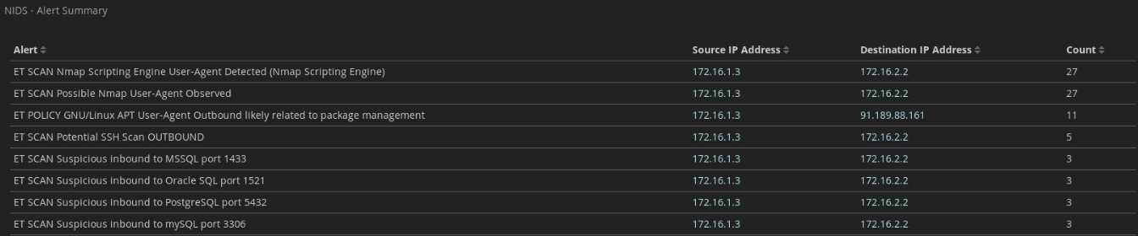

Bro was able to detect the port scan by the nmap and produce an alert.

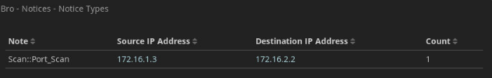

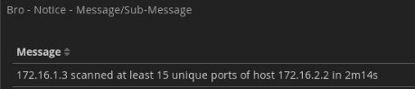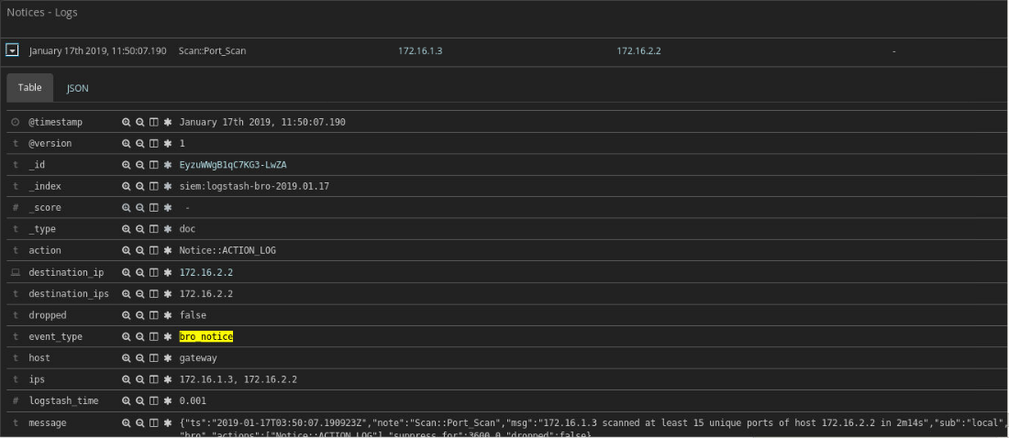

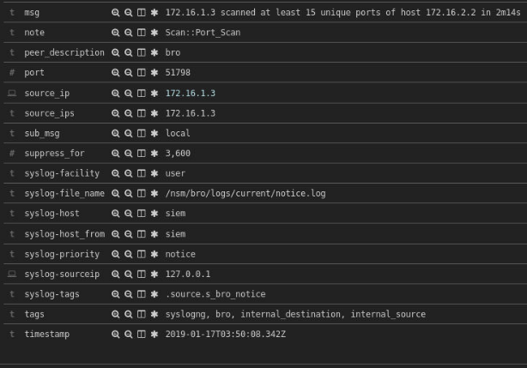

## Combined Network Traffic

### Network Traffic generated by Tools

After capturing the network traffic using tcpdump, I had to use tcprewrite to recalculate and fix the checksum.

<https://groups.google.com/forum/#!msg/security-onion/j_eeVaRdw50/2u3rCu5mAAAJ>



After using tcprewrite on all the pcap files, I will replay them at the same time.

Normal Traffic:





Attack Traffic:











#### Sguil

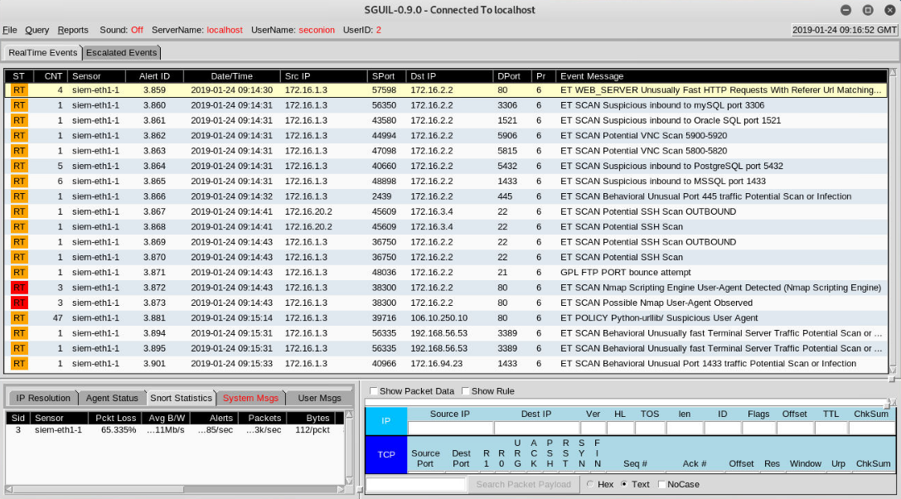

#### Kibana

Snort

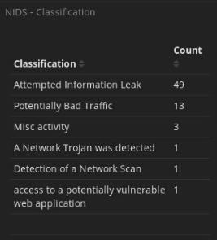

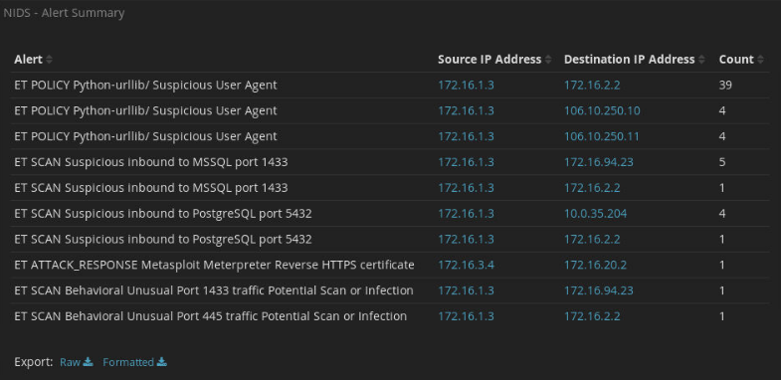

Bro

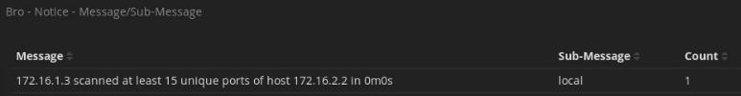

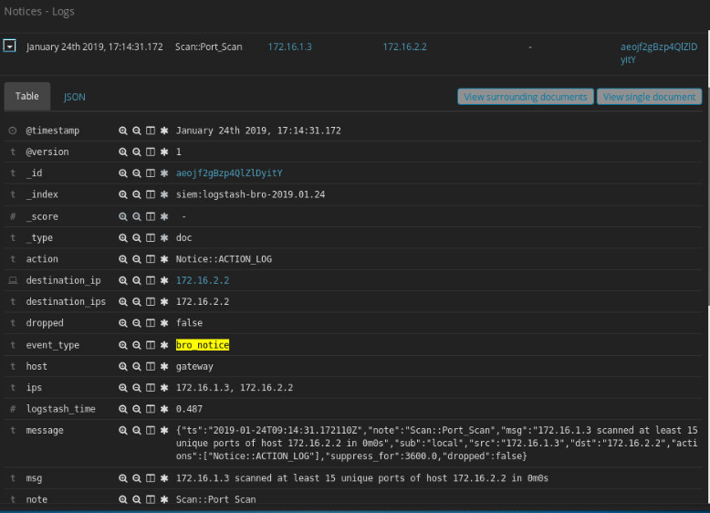

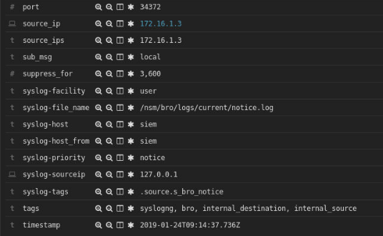

### Self-Generated User Behavior with Attack Traffic

This is the same user behavior traffic generated in 7.1.3.





Normal Traffic:



Attack Traffic:











#### Sguil

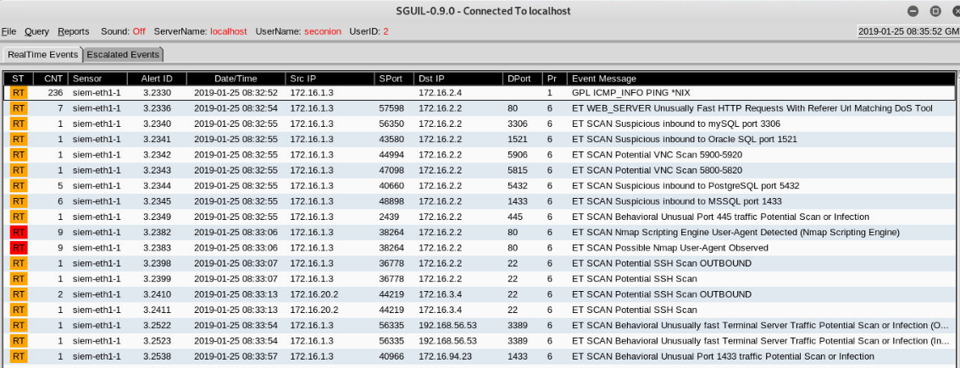

#### Kibana

**Snort**

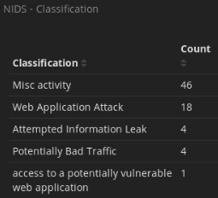

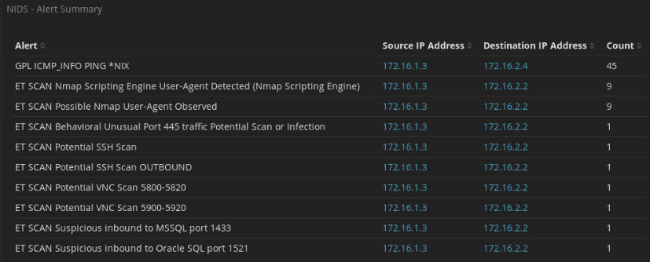

**Bro**

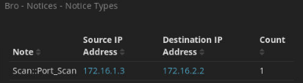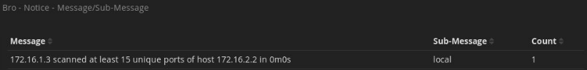

### Downloaded User Behavior with Attack Traffic

Normal Traffic:







Attack Traffic:











#### Sguil

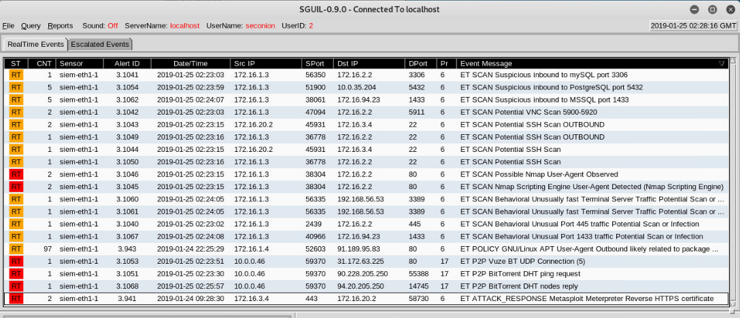

#### Kibana

Snort

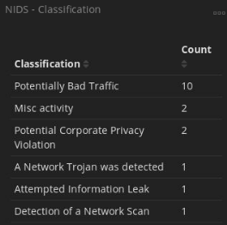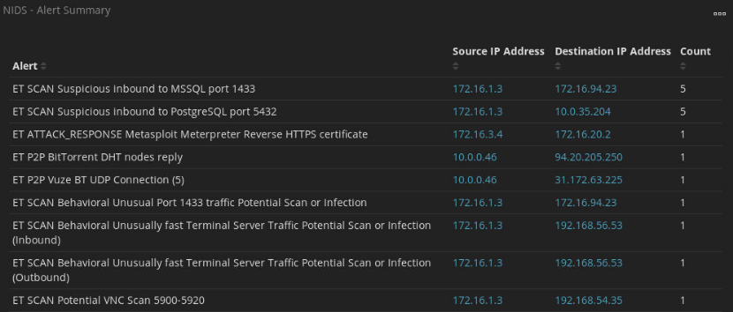

**Bro**

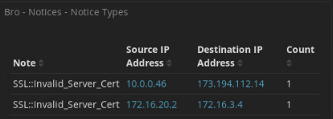

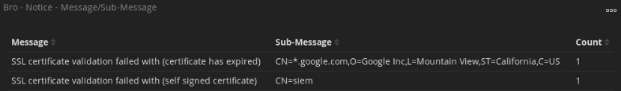

## Conclusion

In conclusion, Security Onion can be deployed and used immediately on small scale organizations. Bro alerts did not work well possibly due to insufficient network traffic in the network as it is an anomaly-based NIDS. If possible, it is recommended to download and use the ISO image provided by Security Onion. This will minimize the problems encountered during the installation and deployment.

<https://github.com/Security-Onion-Solutions/security-onion/wiki/QuickISOImage>